**Computer Specifications**

|  |
| --- |
| **Model: Personal Spec PC**  **Processor: Intel(R) Core (TM) i7-10700F CPU, 2.90GHz**  **Number of Cores: 8 Cores, runs 16 threads**  **Memory: 16 GB RAM** |

SUM(a)

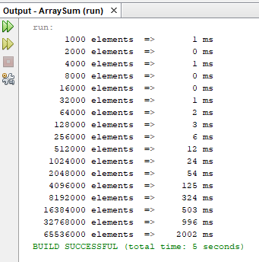

SUM2(a)

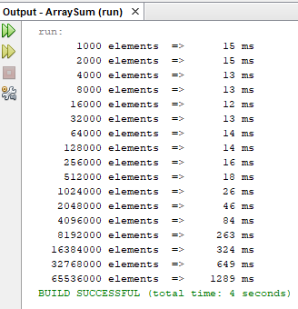

SUM3(a,4)

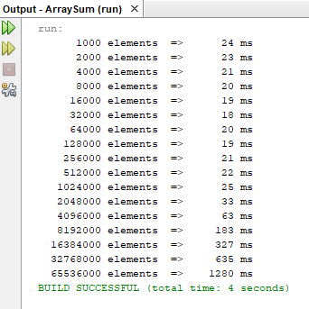

SUM3(a,6)

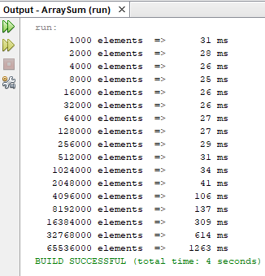

SUM3(a,8)

